
Lab Program Number: 35 Date: 20th March,2026
Title: Security Enhanced Linux (SE Linux).

- Check Current Status of SE Linux.
Command:
Output:
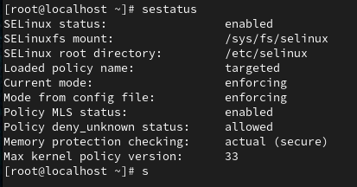

- Configure the server to enable (enforcing) SE Linux.
Command:
Output: (verifying)
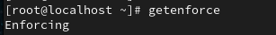

Finding SELINUX: disable OR SELINUX: permissive and changing it to
SELINUX: enforcing

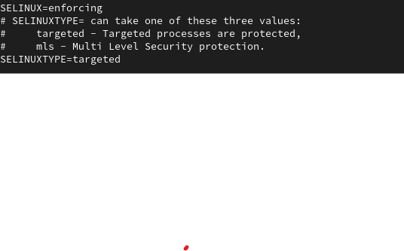

Reboot:

